**C# CSV conversion program version 1**

The program opens an instance of Excel and loads the excel file called invoice.xls and runs the macro in PERSONAL.XLBS.

The converted file is saved to C:\CSV\invoice_output.xls

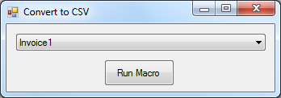

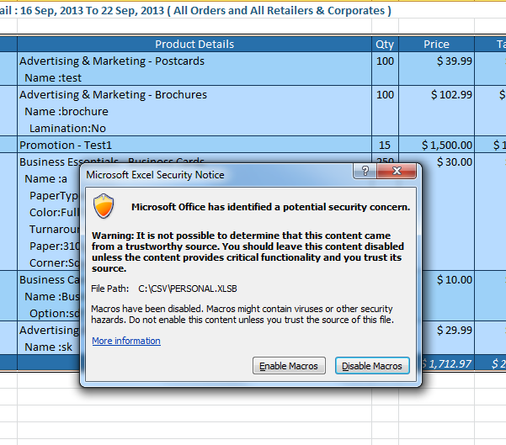

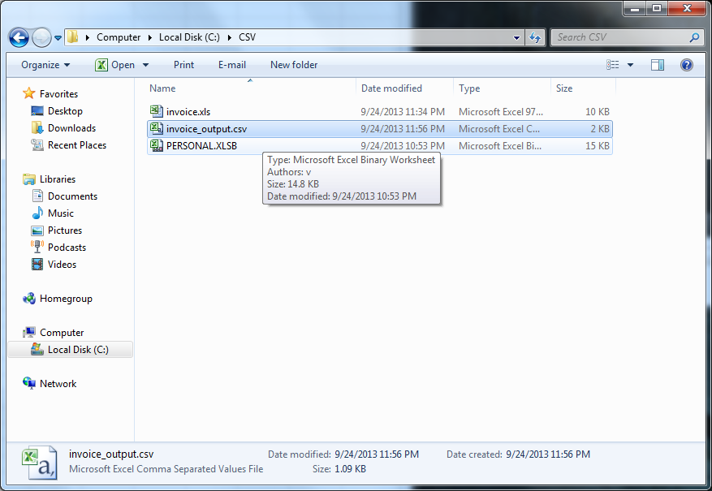

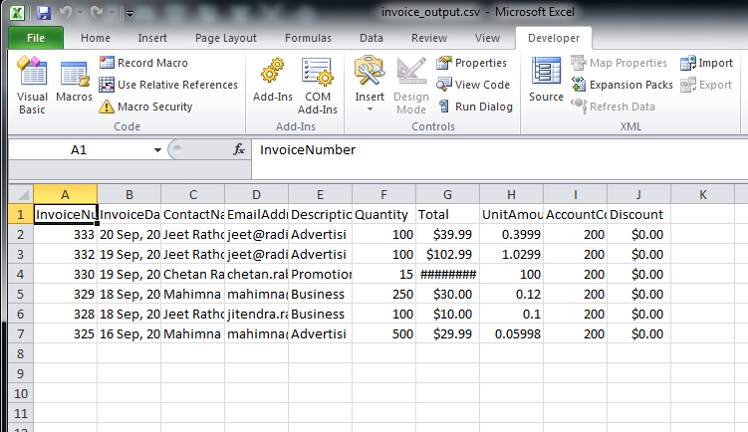

**C# CSV conversion program version 2**

**Change notes:**

Uses Macro v4.2 module

Supports files other than “invoice.xls”

Automatically searches for all excel files in the C:/CSV directory and loads them into the combobox

GUI improvements